Title of the Paper (Times New Roman 14, bold, left-aligned)

Name of the author(s) (Times New Roman 12, bold, left-aligned)
University (Times New Roman 11, left-aligned)
School, Department
Address
City, Postcode
Country
e-mail: your@email.edu

Abstract
abstract (6-12 lines, Times New Roman 11, italic, block-aligned), abstract (6-12 lines, Times New Roman 11, italic, block-aligned), abstract (6-12 lines, Times New Roman 11, italic, block-aligned), abstract (6-12 lines, Times New Roman 11, italic, block-aligned), abstract (6-12 lines, Times New Roman 11, italic, block-aligned), abstract (6-12 lines, Times New Roman 11, italic, block-aligned), abstract (6-12 lines, Times New Roman 11, italic, block-aligned), abstract (6-12 lines, Times New Roman 11, italic, block-aligned), abstract (6-12 lines, Times New Roman 11, italic, block-aligned), abstract (6-12 lines, Times New Roman 11, italic, block-aligned), abstract (6-12 lines, Times New Roman 11, italic, block-aligned), abstract (6-12 lines, Times New Roman 11, italic, block-aligned), abstract (6-12 lines, Times New Roman 11, italic, block-aligned)

Keywords: five, keywords, maximum
JEL codes: five, JEL codes, maximum

1. Introduction (First-level heading, Times New Roman 11, bold)

Normal text of the paper (Times New Roman 11, block-aligned, first line in the paragraph has 1.25 cm indent), normal text of the paper (Times New Roman 11, block-aligned, first line in the paragraph has 1.25 cm indent), normal text of the paper (Times New Roman 11, block-aligned, first line in the paragraph has 1.25 cm indent).

1.1 Model and Data (Second-level heading, Times New Roman 11, bold, italic)

Normal text of the paper (Times New Roman 11, block-aligned, first line in the paragraph has 1.25 cm indent), normal text of the paper (Times New Roman 11, block-aligned, first line in the paragraph has 1.25 cm indent), normal text of the paper (Times New Roman 11, block-aligned, first line in the paragraph has 1.25 cm indent), normal text of the paper (Times New Roman 11, block-aligned, first line in the paragraph has 1.25 cm indent).

1.1.1 Model Calibration (Third-level heading, Times New Roman 11, italic)

Normal text of the paper (Times New Roman 11, block-aligned, first line in the paragraph has 1.25 cm indent), normal text of the paper (Times New Roman 11, block-aligned, first line in the paragraph has 1.25 cm indent), normal text of the paper (Times New Roman 11, block-aligned, first line in the paragraph has 1.25 cm indent).

2. Format Guidelines

Tables and figures should be numbered and references to them must be in the text. Acceptable labeling for a table is Table 1 and Figure 1 for a figure. The title of the table or figure is placed above and the source below the table or figure. The text should be composed in such a manner that there are not a greater number figures or tables on a single page. Tables and figures in landscape format are not acceptable.

Table 1: Title of the Table (Times New Roman, 11, centered)
 | 1998 | 1999 | 2000 | 2001 | 2002
Poland
Russia
Sweden
Source: please provide a source website, paper, author’s calculations, etc.

Figure 1: US Dollar to Swedish Krona Exchange Rate
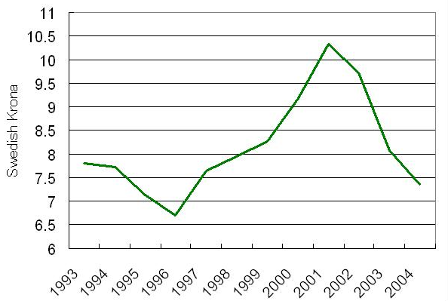
Source: National Bank of Sweden

Equations and formulas are denoted by numbers in round parentheses and it is recommended to be produced by Editor of equations or inserted by the jpg format.

(1)
(2)
(3)
(4)
λ_{j} ≥ 0, j = 1,2,…,n (5)

Bibliographic citation must be in accordance to examples provided below. The list of references should be complete and accurate. For each work shown in the list of references must be a reference in the text. Citation in the text must be according to following rules:
- 1 author
  - Stavárek (2004) has argued that...
  - ...This was seen in a Czech study (Stavárek, 2004).
- 2 authors
  - ... should be considerably improved (McCarty and Yaisawarng, 1993).
  - McCarty and Yaisawarng (1993) suggest application of …
- 3 and more authors: cite only the first name followed by et al.
  - ... should be considerably improved (Brown et al., 1990).
  - Brown et al. (1990) suggest application of …
3. Conclusion

Each paper must include a numbered section of conclusion in which a summary of the key findings should be provided to readers.

Acknowledgement

Please acknowledge any financial support, grant, project in this special section right after the conclusion.

References

Use the provided citation style for references
Make the list of references in alphabetical order
DO NOT NUMBER the references
The list of references must contain only items cited in the text

Citation of a book
POLOUČEK, S. (2004). Reforming the Financial Sector in Central European Countries. Houndmills: Palgrave Macmillan.

Citation of a book chapter
McCARTY, T., YAISAWARNG, S. (1993). Technical Efficiency in New Jersey School Districts. In FRIED, H.O.. LOVELL, C.A.K., SCHMIDT, S.S (eds.) The Measurement of Productive Efficiency: Techniques and Applications. Oxford: Oxford University Press, pp. 98–120.

Citation of a journal paper
STAVÁREK, D. (2004). Banking Efficiency in Visegrad Countries Before Joining the European Union. European Review of Economics and Finance, vol. 3, no. 3, pp. 129–167.

Citation of a working paper
KWAN, S.H. (2002). The X-Efficiency of Commercial Banks in Hong Kong. FRCSF Working Paper 2002-14. San Francisco: Federal Reserve Bank.

Citation of a paper published in conference proceedings
STAVÁREK, D. (2004). An Empirical Investigation of the Relations Between Stock Prices and Exchange Rates. In Proceedings of the Third International Symposium on Business Administration. Gelibolu, Çanakale: Çanakale Onsekiz Mart University, pp. 793–811.

